**Microservices using Java - OTJ for Developer**

**Assignment Submission Form**

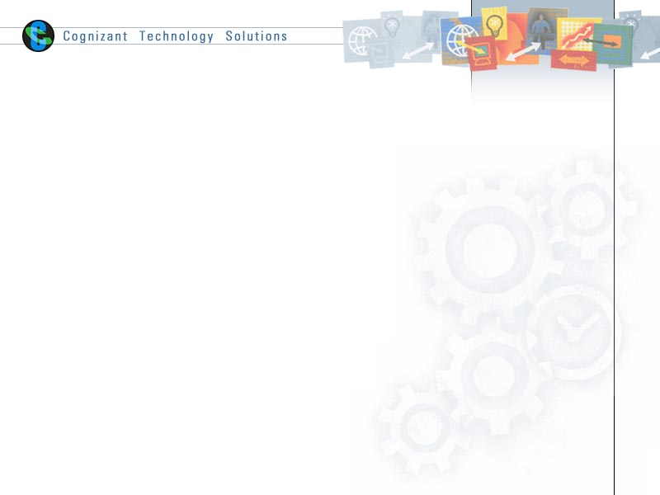

|  |
| --- |
| 1. **On the Job Training (OTJ) Code**: **ATHPP015320** 2. **On the Job Training (OTJ) Name: Microservices using Java(IPM) - OTJ for Developer** 3. **Project Name/Group: EAS** 4. **Vertical/Horizontal: IPM** |

**Instruction to Associates:**

   Please solve the case study in order to complete this action learning. Please follow these steps :

Schedule a lab instance of CTHPP012973 and complete the development.

1. Once completed, take a code backup on github
2. Fill the checklist below and submit this document as OTJ assignment.
3. System will automatically route this OTJ to one SME from a panel.  You will receive a copy of the SME assignment email. Please schedule 30 min Webex or Skype call (where you can do screen sharing) with SME to give demo and answer SME questions within 5 days of submitting this OTJ.
4. Once you have completed the demo, SME will evaluate you and submit the score on the system. You will receive an email notification with the result.

**Please note** : In case, lab access expires due to any reason before you are able to do the demo , you can register for lab again by using activity code given above. Use backup from git-hub to setup your program and reschedule the call with SME.

Select the checkbox for the below Evaluation parameters based on your completion.

|  |  |
| --- | --- |
| **Evaluation Parameters** | **Status(Select Check Box to mark completed)** |
| Eureka server configured on local environment (Toolwire lab) |  |
| Circuit breaker implemented using Hystrix |  |
| Spring Cloud Config Server created |  |
| Load balancing using ribbon  Implemented |  |
| Config server created in Pivotal Cloud Environment |  |
| Eureka server is created in Pivotal cloud environment. |  |

**Instruction to SME:**

Please accept invite from associate and attend the demo. Go through the Rubrics evaluation parameters and correspondingly evaluate the OTJ based on the points/marks provided for each parameter.